**Documentation for the Video Generation Application**

Before you start the application, please double-check the information stored in the **.env** file.

# Taking Screenshots:

Launch the **Screenshot Processor.exe** file, and it will prompt you to enter the path to the CSV file:

Copy the CSV file path and paste it here, ensuring there are no double quotation marks. Press enter and the application will begin collecting screenshots.

## Here’s how it works:

The application processes four URLs simultaneously, loading and waiting for the websites to fully load before capturing screenshots. It saves the captured images in the screenshot folder and adds an entry to the url_screenshot table in the database.

**Main Application:**

Launch the **Main App.exe** and click on the "Connect" button to establish a connection. The application will retrieve data from the **.env** file.

# Feature 1: Cleanup Screenshots:

After taking screenshots, some low-quality or unusable images may not be used for generating videos. In such cases, you will see an option to specify a maximum file size in kilobytes for deleting screenshots. This feature will remove both the images and the corresponding database entries based on your input.

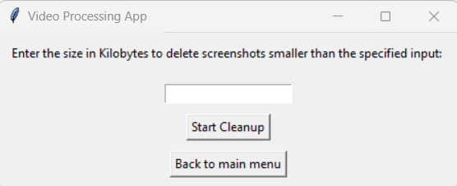

# Feature 2: Video Preparation

Prior to initiating the video processor, please verify that the **video_description.txt** and **video_title.txt** files contain the correct data in the **static** folder. You can utilize any column name from the selected table as a variable within the text file, such as "{root_domain}," and more. For additional instructions, refer to the provided image.

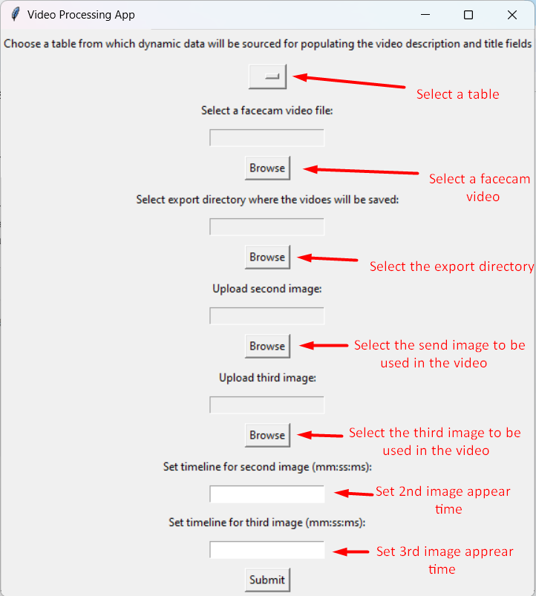

The image provides essential instructions for input.

## Here's how it works:

It captures four screenshots simultaneously and begins processing them with additional images and user-provided timing input to generate videos. Once video rendering is complete, it saves the video in the specified export folder and inserts the video path, description, and title into the **url_videos** table in the database.

# Feature 3: Upload to Video Server

Selecting this option will check for available videos to upload to the video server.

## Here's how it functions:

It first checks the url_videos table for null values in the "youtube_link" column and initiates the upload process after receiving your confirmation. Upon completing the upload, it inserts the live URL link and deletes the video file locally. Additionally, it captures the first frame as a thumbnail for the video and stores it in the **thumbnail** folder.

# Feature 4: Generate WP Pages

Before proceeding with WP page generation, please ensure you have configured the **wp_template.html** and **wp_page_title.html** files in the **static** folder with the appropriate content and variables. Select the table to populate the variables and set the page status.

## Here's how it works:

It identifies records with null values in the "wp_link" column within the url_videos table and starts uploading. Once completed, it inserts the live WP link into the database.